Le culendrier de 2001

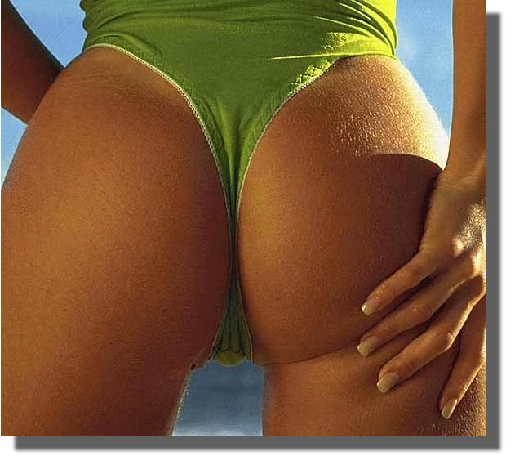 |  |  |  |  |  |  |  |  |  |  |  |  |  |  |  | 
Janvier |  |  |  |  |  |  |  | Fevrier |  |  |  |  |  |  |  | Mars
D | L | M | M | J | V | S |  | J | V | S | D | L | M | M |  | J | V | S | D | L | M | M
 | 1 | 2 | 3 | 4 | 5 | 6 |  | 1 | 2 | 3 | 4 | 5 | 6 | 7 |  | 1 | 2 | 3 | 4 | 5 | 6 | 7
7 | 8 | 9 | 10 | 11 | 12 | 13 |  | 8 | 9 | 10 | 11 | 12 | 13 | 14 |  | 8 | 9 | 10 | 11 | 12 | 13 | 14
14 | 15 | 16 | 17 | 18 | 19 | 20 |  | 15 | 16 | 17 | 18 | 19 | 20 | 21 |  | 15 | 16 | 17 | 18 | 19 | 20 | 21
21 | 22 | 23 | 24 | 25 | 26 | 27 |  | 22 | 23 | 24 | 25 | 26 | 27 | 28 |  | 22 | 23 | 24 | 25 | 26 | 27 | 28
28 | 29 | 30 | 31 |  |  |  |  |  |  |  |  |  |  |  |  | 29 | 30 | 31

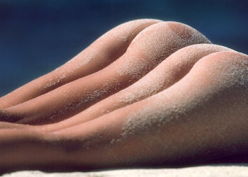 |  |  |  |  |  |  |  |  |  |  |  |  |  |  |  | 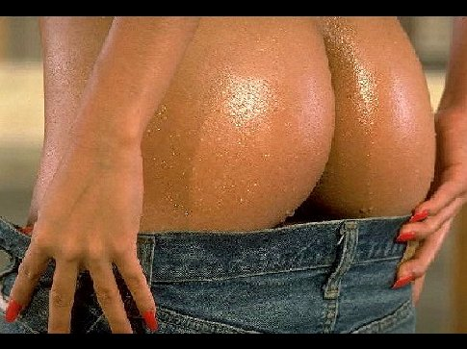
Avril |  |  |  |  |  |  |  | Mai |  |  |  |  |  |  |  | Juin
D | L | M | M | J | V | S |  | M | M | J | V | S | D | L |  | M | M | J | V | S | D | L
1 | 2 | 3 | 4 | 5 | 6 | 7 |  | 1 | 2 | 3 | 4 | 5 | 6 | 7 |  | 1 | 2 | 3 | 4 | 5 | 6 | 7
8 | 9 | 10 | 11 | 12 | 13 | 14 |  | 8 | 9 | 10 | 11 | 12 | 13 | 14 |  | 8 | 9 | 10 | 11 | 12 | 13 | 14
15 | 16 | 17 | 18 | 19 | 20 | 21 |  | 15 | 16 | 17 | 18 | 19 | 20 | 21 |  | 15 | 16 | 17 | 18 | 19 | 20 | 21
22 | 23 | 24 | 25 | 26 | 27 | 28 |  | 22 | 23 | 24 | 25 | 26 | 27 | 28 |  | 22 | 23 | 24 | 25 | 26 | 27 | 28
29 | 30 |  |  |  |  |  |  | 29 | 30 | 31 |  |  |  |  |  | 29 | 30

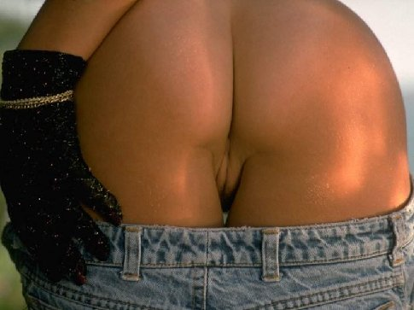 |  |  |  |  |  |  |  | 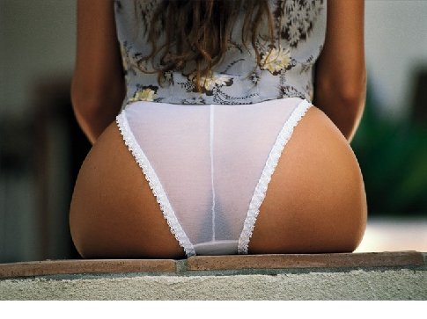 |  |  |  |  |  |  |  | 
Juillet |  |  |  |  |  |  |  | Aout |  |  |  |  |  |  |  | Septembre
J | V | S | D | L | M | M |  | D | L | M | M | J | V | S |  | M | J | V | S | D | L | M
1 | 2 | 3 | 4 | 5 | 6 | 7 |  | 1 | 2 | 3 | 4 | 5 | 6 | 7 |  | 1 | 2 | 3 | 4 | 5 | 6 | 7
8 | 9 | 10 | 11 | 12 | 13 | 14 |  | 8 | 9 | 10 | 11 | 12 | 13 | 14 |  | 8 | 9 | 10 | 11 | 12 | 13 | 14
15 | 16 | 17 | 18 | 19 | 20 | 21 |  | 15 | 16 | 17 | 18 | 19 | 20 | 21 |  | 15 | 16 | 17 | 18 | 19 | 20 | 21
22 | 23 | 24 | 25 | 26 | 27 | 28 |  | 22 | 23 | 24 | 25 | 26 | 27 | 28 |  | 22 | 23 | 24 | 25 | 26 | 27 | 28
29 | 30 | 31 |  |  |  |  |  | 29 | 30 | 31 |  |  |  |  |  | 29 | 30

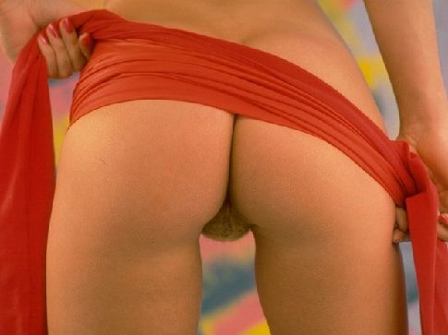 |  |  |  |  |  |  |  |  |  |  |  |  |  |  |  | 
Octobre |  |  |  |  |  |  |  | Novembre |  |  |  |  |  |  |  | Décembre
V | S | D | L | M | M | J |  | L | M | M | J | V | S | D |  | M | J | V | S | D | L | M
1 | 2 | 3 | 4 | 5 | 6 | 7 |  | 1 | 2 | 3 | 4 | 5 | 6 | 7 |  | 1 | 2 | 3 | 4 | 5 | 6 | 7
8 | 9 | 10 | 11 | 12 | 13 | 14 |  | 8 | 9 | 10 | 11 | 12 | 13 | 14 |  | 8 | 9 | 10 | 11 | 12 | 13 | 14
15 | 16 | 17 | 18 | 19 | 20 | 21 |  | 15 | 16 | 17 | 18 | 19 | 20 | 21 |  | 15 | 16 | 17 | 18 | 19 | 20 | 21
22 | 23 | 24 | 25 | 26 | 27 | 28 |  | 22 | 23 | 24 | 25 | 26 | 27 | 28 |  | 22 | 23 | 24 | 25 | 26 | 27 | 28
29 | 30 | 31 |  |  |  |  |  | 29 | 30 |  |  |  |  |  |  | 29 | 30 | 31

